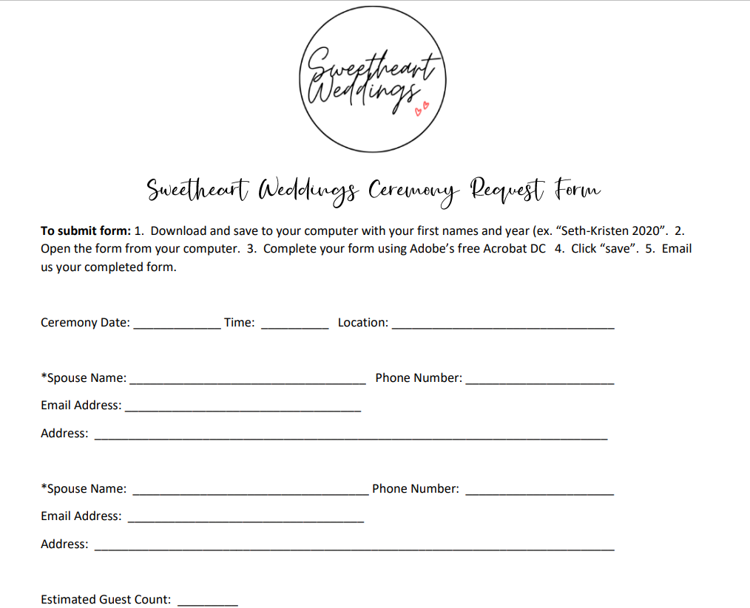

Select Package: | Select Theme: | Select Ceremony (If Applicable):
- Premier | - Colorado Rustic | - Wedding
- Primary | - Loveland Classic | - Vow Renewal
- Simple Elopement | - NOCO Boho | - Family Promise

Payment Methods: Deposit payments can be made by cash, check, Venmo, or credit card.
Venmo: Click Here for access to Sweetheart Weddings Venmo or scan QR code provided.
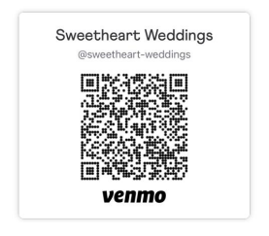
Credit Card Information:
Name on card: ___________________________________________________
Card number: _________________________________ Expiration Date: ________________________
Security Number: ________________ Zip Code: ________________

- Sweetheart Weddings reserves the right to charge the above credit card 30 days prior to your ceremony date the remaining ceremony balance if a Change Request Form is not submitted to cancel the ceremony.
- Ceremony balance is due 30 days prior to ceremony date. If the wedding is canceled within 60 days of the ceremony date, there will be no refund and the couple is responsible for the remaining cost of all package/upgrade items ordered. If postponed outside of 60 days, the $500 deposit will be retained as the cancellation fee.
- Package specifics and upgrade services may be modified up to 30 days prior to your ceremony.
- Sweetheart Weddings is not responsible for inclement weather.
I have read and agree to the terms as stated above.

Spouse Signature: ________________________ Spouse Signature: _______________________

970-840-9222
bratten@sweetheart-weddings.com
www.sweetheart-weddings.com

